ROCKY MOUNTAIN HOUSE SPEED SKATING CLUB
Skater Registration Form • 2020-2021

Name
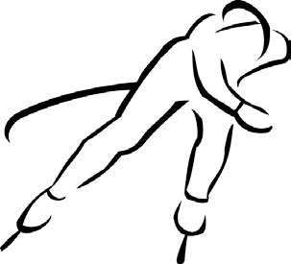
Date of Birth Age as of July 1, 2020
Gender Alberta Health Care Number
Parents’/Guardians’ Names Address
Phone (home) (work) Email address
Free Trial with Group 1
Tuesdays & Thursdays, 5:15-6:15 p.m.
(2 weeks/4 sessions) at the Kootenay Arena
Please have your child dressed and ready to step on the ice promptly at 5:15. Every child must be wearing the proper protective gear:
hockey skates helmet __knee pads __safety glasses
shin pads __neck protector __leather gloves

PLEASE READ AND SIGN THE RELEASE

The above named child has my full permission to participate in the RMHSSC free trial program. I do hereby release, absolve, indemnify and save harmless the Rocky Mountain House Speed Skating Club, their supervisors, coaches and any and/or all of his/her members. I do assume all risks and hazards incidental to the activity and hereby waive all claims which the said child or I may have against the above organization or individuals.

Signature Date

I understand that RMHSSC offers a 2-week trial period. Upon completion of the free trial, I must complete the online registration process and settle all fees if my child wishes to continue skating.

Parents’ Signature

